**Time Series**

**Time Series Forecasting :**

Time series is a set of observations on the values that a variable takes at different times.

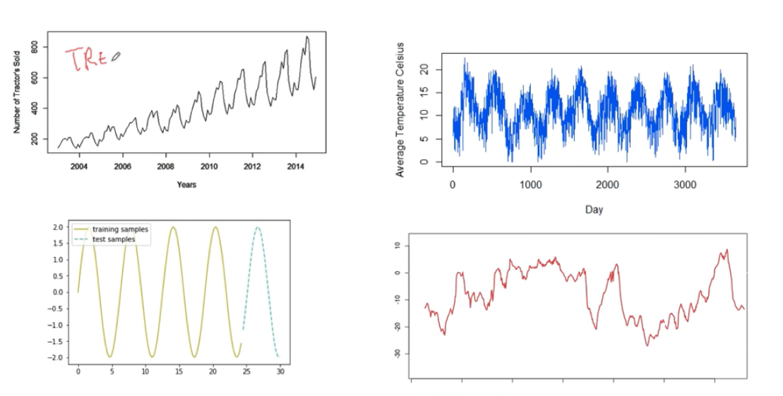

**White Noise :**

A series purely random in nature is called as white noise

Average is the best forecast of the series.

**Auto Regressive Model(RA) :**

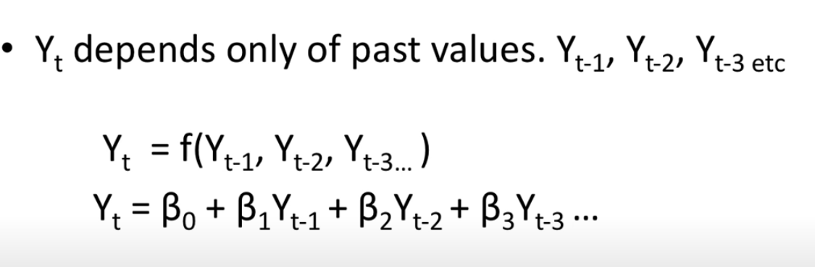

**Moving Average Model(MA):**

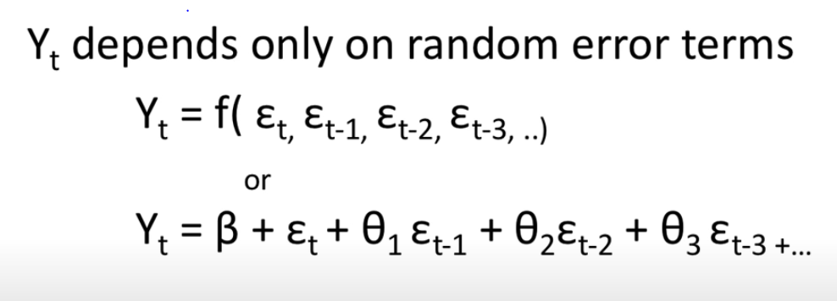

**ARIMA Model:**

Auto Regressive Integrated Moving Average.

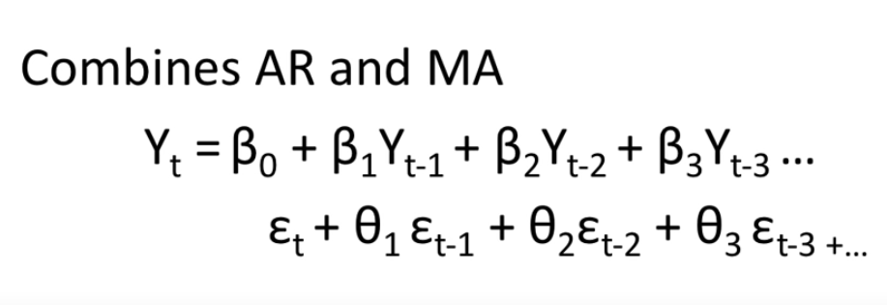

**Stationarity is important :**

Most model assumes stationarity of data. In other words standard techniques are invalid if data is non-stationary.

**Auto Correlation :**

Auto correlation is the similarity between observations as the function of the time lag between them

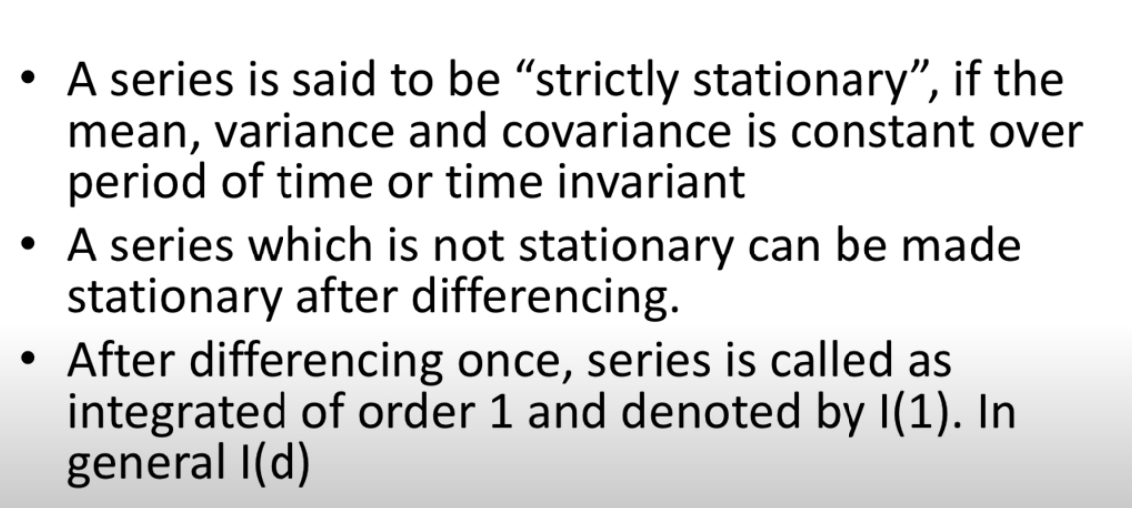

**Akaike Information Criteria :**

